**Pengiriman Data Melalui Python**

# sudo apt-get update -y  
# sudo apt-get install -y python-stomp  
# mkdir code_python  
# cd code_python/

# nano stomp-send-rabbit.py

*import stomp*

*import time*

*import sys*

*class MyListener(stomp.ConnectionListener):*

*def on_error(self, headers, message):*

*print('received an error "%s"' % message)*

*def on_message(self, headers, message):*

*print('received a message "%s"' % message)*

*conn = stomp.Connection([('127.0.0.1', 61613)])*

*conn.set_listener('', MyListener())*

*conn.start()*

*conn.connect('admin', '123456', wait=True)*

*conn.send(body='SUHU 10', destination='/queue/test')*

*conn.disconnect()*

# chmod 755 stomp-send-rabbit.py

# python stomp-send-rabbit.py

Buka web Rabbit MQ, perhatikan pada menu Queue, terbentuk queue dengan nama test.

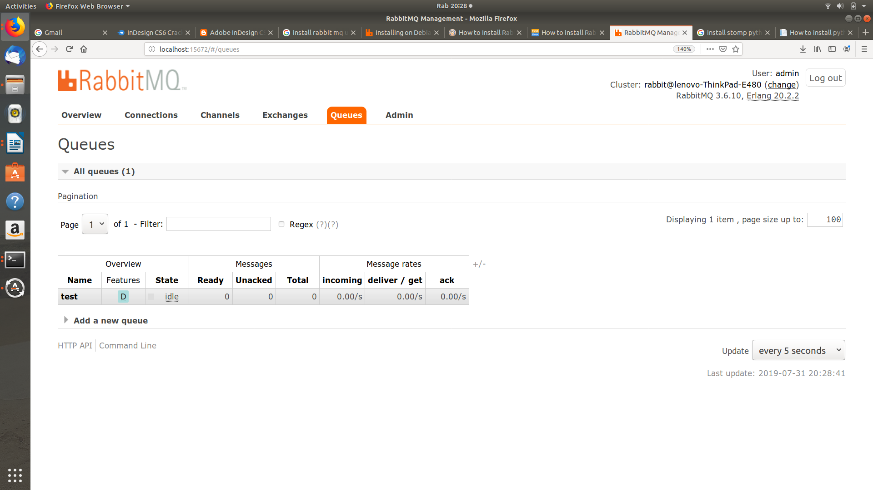

Kemudian klik queue test, perhatikan bahwa ada data yang masuk melalui stomp.

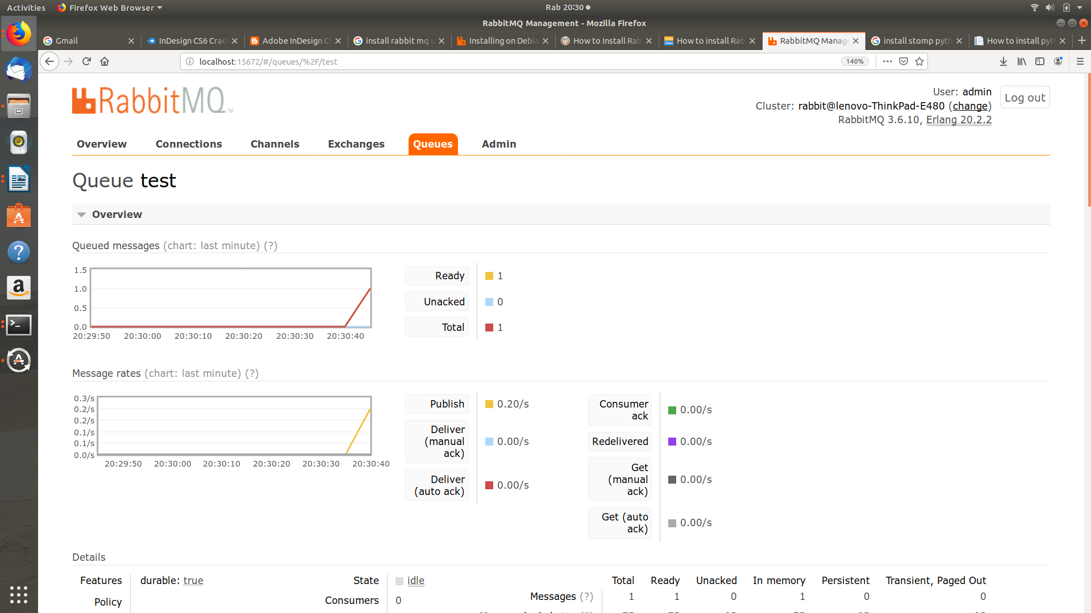

**Pembacaan Data Melalui Python**

# nano stomp-receive-rabbit.py

*import stomp*

*import os*

*import time*

*class MyListener(stomp.ConnectionListener):*

*def on_error(self, headers, message):*

*print('received an error "%s"' % message)*

*def on_message(self, headers, message):*

*print('received a message "%s"' % message)*

*conn = stomp.Connection([('127.0.0.1', 61613)])*

*conn.set_listener('', MyListener())*

*conn.start()*

*conn.connect('admin', '123456', wait=True)*

*conn.subscribe(destination='/queue/test', id=1, ack='auto')*

*time.sleep(1000)*

*conn.disconnect()*

# chmod 755 stomp-receive-rabbit.py

# python stomp-receive-rabbit.py

received a message "SUHU 10"